Camera Windows Update Checker

Installation: Right-Click on the “UpdateChecker.bat” file and select “Run as administrator”

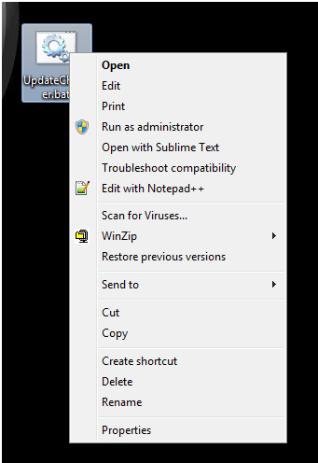

Updates to checker: